**Article On Wine Quality Prediction**

**1. Problem Definition:-**

**i)Background:-** Wine quality assessment is a complex and nuanced process traditionally performed by human experts, such as sommeliers, who rely on their refined senses of taste, smell, and sight. However, subjective assessments can vary widely due to individual preferences and biases. The advent of machine learning offers a promising alternative: using data-driven approaches to predict wine quality based on measurable chemical properties. This objective method can enhance consistency and reliability in wine quality evaluation, benefiting winemakers, distributors, and consumers.

**ii)Objective:-**The primary objective is to develop a machine learning model capable of predicting the quality of red wine based on its physicochemical properties. This model aims to assist winemakers in maintaining consistent quality and aiding consumers in making informed choices.

**iii)Dataset:-**The dataset used for this analysis is the Red Wine Quality Dataset, which I have downloaded from github.It contains 1,599 samples of red wine from the Portuguese "Vinho Verde" region. Each sample includes 11 physicochemical properties and one sensory variable (quality), which is the target variable.

**iv)Features:-** This dataset includes different types of features:-

* **Fixed Acidity:** Refers to acids that do not evaporate readily. It impacts the taste and preservation of the wine.
* **Volatile Acidity:-** Represents acetic acid, which in high concentrations can lead to an unpleasant vinegar taste.
* **Citric Acid:-** Adds freshness and flavor to the wine.
* **Residual Sugar:-**The amount of sugar left after fermentation. It influences the sweetness of the wine.
* **Chlorides:-** A measure of the salt content, affecting the wine's taste.
* **Free Sulfur Dioxide:-** Acts as an antimicrobial and antioxidant, important for preventing spoilage.
* **Total Sulfur Dioxide:-** The total amount of free and bound sulfur dioxide, crucial for wine preservation.
* **Density:-** Closely related to the sugar and alcohol content.
* **pH:-** Indicates the acidity level, affecting the wine's stability and taste.
* **Sulphates:-** Contributes to the wine’s bitterness and acts as a preservative.
* **Alcohol:-** The percentage of alcohol content, impacting the body and warmth of the wine.

The target variable is the quality score, which ranges from 0 (very poor) to 10 (excellent), as determined by expert tasters.

**2. Data Analysis**

**i)Initial Exploration:-** Data analysis begins with an initial exploration to understand the dataset's structure and check for any issues such as missing values, inconsistencies, or outliers. This step is crucial for ensuring the integrity of the data before proceeding to more complex analyses and model building.

**ii)Summary Statistics:-** Summary statistics provide a comprehensive overview of the dataset. They include measures of central tendency (mean, median), dispersion (standard deviation, interquartile range), and the range (minimum and maximum values). These statistics help identify any anomalies or unexpected patterns in the data.

For instance, the mean and median values of the quality scores can reveal whether the distribution of the target variable is skewed. Standard deviations can indicate the variability within each feature, and extreme minimum or maximum values can suggest the presence of outliers.

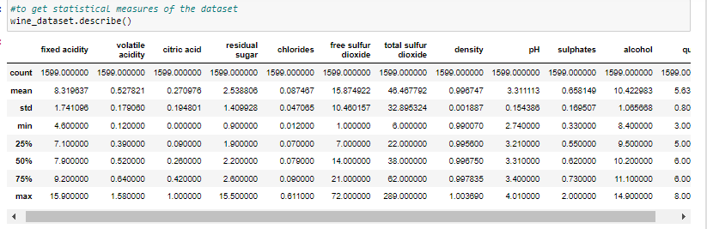

**iii)Correlation Analysis :-** Correlation analysis helps understand the relationships between the features and the target variable. By calculating the correlation coefficients, we can identify which features have the strongest associations with wine quality. A correlation matrix can visually represent these relationships, making it easier to spot highly correlated features. Key observations from correlation analysis might include:

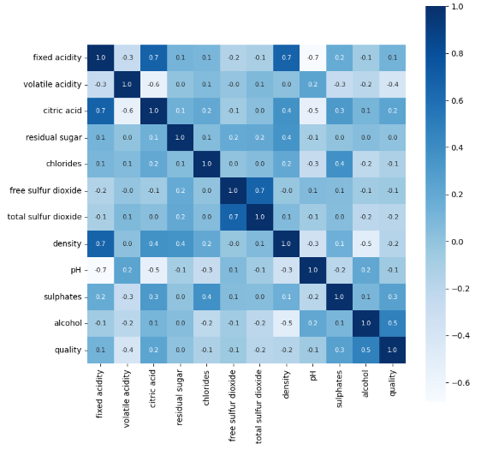

Here we can observe that i.e in the last(quality) column that alcohol, fixed acidity,sulphates and citric acid shows positive correlation with quality attribute, whereas volatile acidity,chlorides,free sulfur dioxide,total sulfur dioxide,density,pH shows negative correlation with quality attribute.

**iv)Distribution of Quality Scores:-** Understanding the distribution of the quality scores is crucial as it affects the modeling approach. For instance, if the scores are heavily skewed towards a particular range (e.g., most wines are rated between 5 and 7), this imbalance can influence model performance and necessitate specific handling strategies, such as stratified sampling or adjusting evaluation metrics. Here we can see count for each quality.

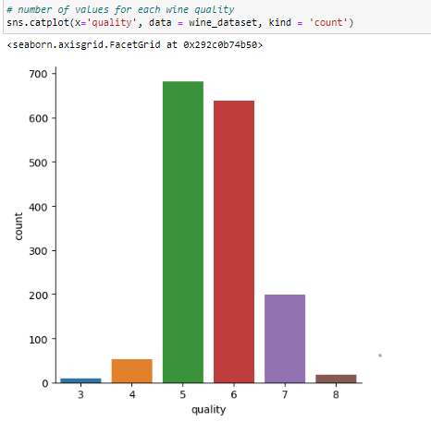

**v)Bivariate analysis:-** Also did bivariate analysis of all 11 features with quality which is our targte variable. Example of bivariate analysis done by me.

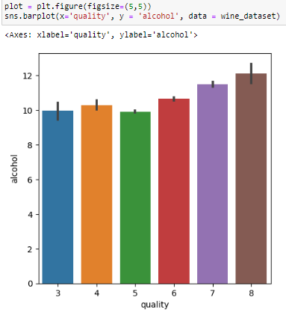

In this we can observe that as alcohol value increases wine quality increases. So alcohol and quality are directly proportional and the values must be in between 11-12 for best quality wine.

**3. EDA Concluding Remarks:-**

Exploratory Data Analysis (EDA) of the Red Wine Quality Dataset yields several important insights:

1. No Missing Values:- The dataset is complete, allowing us to proceed directly to modeling without imputation.
2. Skewed Quality Distribution:- The quality scores are often skewed towards the middle range (5 to 7), indicating that most wines are rated as average. This distribution needs to be considered during model evaluation to ensure the model is not biased towards the majority class.
3. Significant Features:- Features such as alcohol content and volatile acidity show strong correlations with wine quality, making them critical for predictive modeling.
4. Outliers:- Potential outliers identified during the summary statistics review may need to be addressed to prevent them from skewing the model's performance.

These insights guide the preprocessing steps and inform the selection of features for the predictive model.

**4. Pre-processing Pipeline:-**

**i)Data Cleaning:-** Data cleaning involves handling outliers and ensuring data consistency. Although the dataset has no missing values, addressing outliers is essential as they can adversely impact model performance. Techniques such as the interquartile range (IQR) method or z-score analysis can be used to identify and manage outliers. Deciding whether to remove or transform these outliers depends on their potential impact on the analysis.

**ii)Feature Scaling:-** Feature scaling ensures that all features contribute equally to the model's performance by standardizing the range of the data. This step is particularly important for algorithms that rely on distance measures, such as Support Vector Machines (SVM) or K-Nearest Neighbors (KNN). Common scaling techniques include Min-Max Scaling, which scales the data to a fixed range (typically 0 to 1), and Standardization, which transforms the data to have a mean of zero and a standard deviation of one.

**iii)Handling Categorical Variables:-** In our dataset, all features are numerical, so there is no need for encoding categorical variables. However, if categorical data were present, techniques like One-Hot Encoding (which creates binary columns for each category) or Label Encoding (which assigns numerical values to categories) would be necessary.

**iv)Train-Test Split:-**Splitting the dataset into training and testing sets is crucial for evaluating the model's performance. Typically in this dataset we have applied 80-20 split, where 80% of the data is used for training the model, and 20% is reserved for testing. This split ensures that the model's performance is assessed on unseen data, providing a realistic estimate of its generalization capability.

**v)Addressing Class Imbalance:-** If the target variable is imbalanced, with significantly more samples in certain quality ranges (e.g., 5-6) compared to others (e.g., 9-10), techniques such as oversampling the minority class, undersampling the majority class, or generating synthetic samples using methods like SMOTE (Synthetic Minority Over-sampling Technique) can be employed to balance the dataset.

**5. Building Machine Learning Models**

**Model Selection:-** Several machine learning models can be used to predict wine quality, each with its strengths and weaknesses. The following models are considered:

* **Logistic Regression:-** Provides a baseline performance and helps understand the relationships between features and the target variable.
* **Random Forest:-** An ensemble method that improves performance by averaging multiple decision trees, reducing overfitting and increasing accuracy.
* **Gradient Boosting:-** Another ensemble technique that builds trees sequentially, each one correcting the errors of the previous, often leading to high performance.
* **Support Vector Classifier:-** Effective in high-dimensional spaces and useful for regression tasks where the relationship between features and the target is complex.
* **Adaboost Classifier:-** The AdaBoost (Adaptive Boosting) Classifier is an ensemble learning method that combines multiple weak learners, typically decision stumps, to create a strong classifier by adjusting the weights of misclassified instances in successive iterations.
* **Bagging Classifier:-** The Bagging (Bootstrap Aggregating) Classifier is an ensemble method that improves the stability and accuracy of machine learning algorithms by training multiple models on different random subsets of the dataset and combining their predictions.
* **Extra Trees Classifier:-** The Extra Trees (Extremely Randomized Trees) Classifier is an ensemble learning method that builds multiple unpruned decision trees from the original training sample and uses random splits of all the observations at each node to reduce variance and improve predictive accuracy.

**Model Training and Evaluation:-** Each model is trained on the training set and evaluated on the test set using appropriate performance metrics. For logistic regression/classification tasks, common metrics which we use are:- accuracy score,confusion matrix,classification report. These metrics provide insights into how well the model's predictions align with the actual quality scores.

**Hyperparameter Tuning:-**Hyperparameter tuning is essential for optimizing the performance of machine learning models. Techniques such as Grid Search or Randomized Search can systematically explore different hyperparameter values to find the best combination. For example, in a Random Forest model, hyperparameters like the number of trees, maximum depth, and minimum samples split can be tuned to enhance model performance.

**Cross-Validation:-** To ensure the model's robustness and to mitigate overfitting, k-fold cross-validation can be employed. This technique involves splitting the training data into k subsets and training the model k times, each time using a different subset as the validation set and the remaining data as the training set. The average performance across all k iterations is then used to assess the model.

**Model Comparison**:-

Once all models are trained and tuned, their performance is compared using the evaluation metrics. The model with the best overall performance is selected for further refinement or deployment. Factors such as interpretability, training time, and computational resources may also influence the final model selection.

**6. Concluding Remarks**

**i)Summary:-** The objective of predicting red wine quality based on physicochemical properties was approached methodically, involving problem definition, data analysis, exploratory data analysis (EDA), pre-processing, model building, and evaluation. Key findings include the importance of features such as alcohol content and volatile acidity in predicting wine quality.

**ii)Model Performance:-** Among all the 7 models which we have fort prediction of good quality wine, we found that all the model are giving good accuracy but the RandomForestClassifer is giving the best accuracy score of 92.18%, so we should use this model for predicting best quality wine. These models effectively capture the complex relationships in the dataset, leading to accurate predictions of wine quality.

**iii)Practical Implications:-**The developed predictive model has significant implications for the wine industry. Winemakers can use the model to monitor and control the quality of wine during production, ensuring consistency and high standards. Consumers can benefit from more reliable quality assessments, aiding in better purchasing decisions.

**iv)Future Work:-**Future work could explore several avenues:

1. **Feature Engineering:-** Developing new features that might provide additional predictive power, such as interaction terms or domain-specific metrics.
2. **Advanced Models:-** Exploring more sophisticated models like Neural Networks or Deep Learning, which might capture even more intricate patterns in the data.
3. **Domain Integration:-** Incorporating domain knowledge and expert input to refine the model and enhance interpretability.

Overall, the project demonstrates the potential of machine learning to transform traditional domains like wine tasting, offering objective, data-driven insights that complement human expertise. This fusion of technology and tradition can lead to improved products and experiences for both producers and consumers.